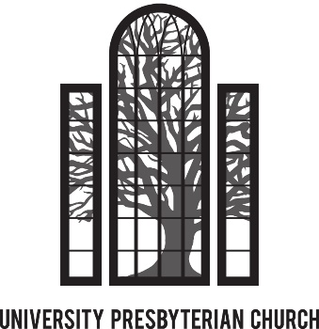

Realm Instructions
September 2019

First Time Setup | Using Realm | Focus on Groups | Profile & Account Settings |Download & Use the App
Realm Online Documentation & Videos

We encourage everyone to create an account with our new Realm software system. Realm is available through both its website (https://onrealm.org/UniversityPresb15909) and the Realm Connect app. Realm is a great resource for committees and service groups to maintain their communications, calendar events and shared files. If you are on a committee or service group at UPC, you will likely be asked to use Realm for its communications. Once you see all the benefits of using Realm for committee functions you will certainly appreciate the ways Realm can help UPC provide better ministry to help fulfill our Mission.

First Time Setup
By now all active UPC members should have gotten an email like the one below from Realm inviting them to set up such an account. If you have not gotten such an email, please check your spam or junk folder. The emails are automated and are identified as spam by some programs. Also, email invitations expire after 72 hours. If you need a new email invitation then please contact Caralyn Durham at cdurham@upcbr.org to send you a new one.

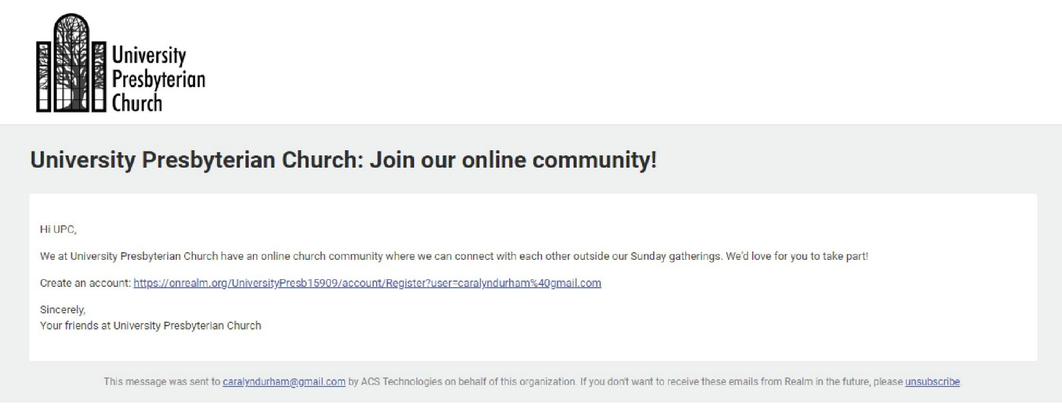

When you click on the “Create Realm Account” link you will be directed to a page like the one on the following page. Unlike AccessACS, in Realm the username is your email address, which is easier to remember. The username you may have used in AccessACS is no longer used.

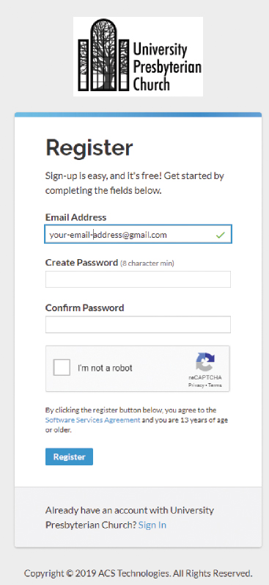
You then must create a password. It must be at least eight characters and have a mix of upper and lower-case letters and numbers or symbols. If your password is acceptable, you’ll see a small green check to the right of what you typed. If not, you’ll see a red marker. When you have set your password, click on the blue “Create Realm Account”. You will then receive another email asking you to verify your email address. Check your email and click on the link to verify. This will put you into Realm and you will be directed to the “News” page that will look something like this:

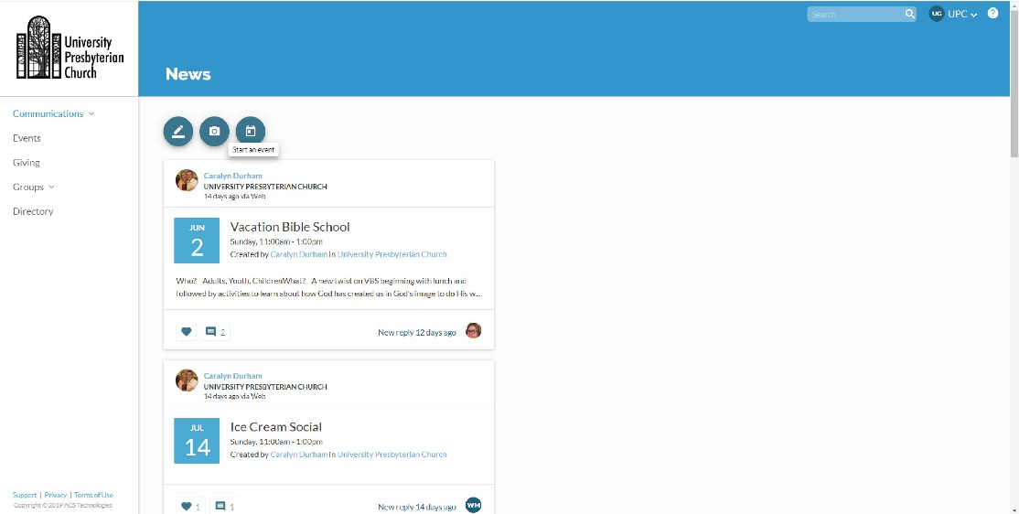

Using Realm
Log into Realm at https://onrealm.org/UniversityPresb15909. The “Community” area of Realm represents the social media portion for church group communications. Realm will default to the “News” page and will display any recent news posted to any of the Groups that you are a participant. Everyone is part of the University Presbyterian Church group.
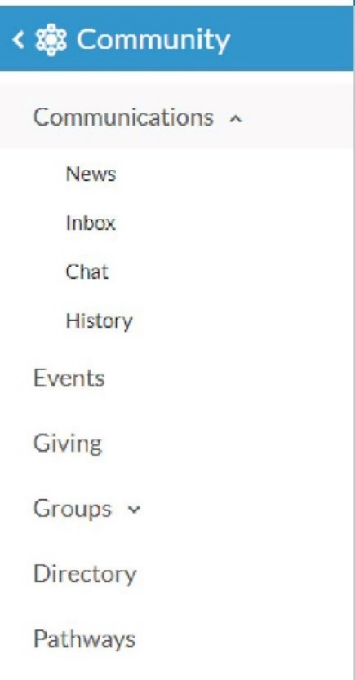
The left menu pane shows the available Community functions…
“Inbox” and “Chat” will display any messages that have been sent to you and is where you can send messages to other members without needing their email address. Once a message is sent the recipient will receive an email they have a message on Realm and also a notification on their smartphone if they have the Realm Connect app.
“Events” will show any calendar events posted for the congregation or for any of the groups you belong to. If you belong to multiple committees, having the Committee meetings as calendar events makes it easy to remember when they occur. If you respond to an event that you will be attending, you will receive an email reminder the day prior to the event.
“Giving” will show your giving to the church. The default setting shows your giving for the current calendar year, but if you click on the “funnel” shaped icon above the “year to date” indicator, you can filter the results to show different date ranges. The print icon will allow you to download a .pdf of the giving record that you can print. The right pane will show your current and past pledges. Once a pledge campaign is active, you can update your pledge as well.

NOTE:
No one except you and the Office Manager has the ability to view your giving information. If you have questions about any of the giving information, please contact the Caralyn Durham at cdurham@upcbr.org.

“Groups” will list the groups or committees you are a part of. Everyone should have “University Presbyterian Church” as a group. The Groups section is the heart & soul of Realm. For that reason, there is dedicated section called “Focus on Groups” that will go into much more detail on using Groups.
“Directory” lists all active UPC members. Clicking on a member’s name should pull up a page with contact and personal information that that person allows you to see. To send a message to the person, click the “Message” icon under the person’s name and follow the prompts. Note that only Realm users who have updated their Privacy to “Everyone in Our Church” will have their contact information show in the Directory. For this reason, it is important that you have your privacy settings set in this way. Refer to the Manage Privacy section for instructions to update your privacy setting.

Focus on Groups
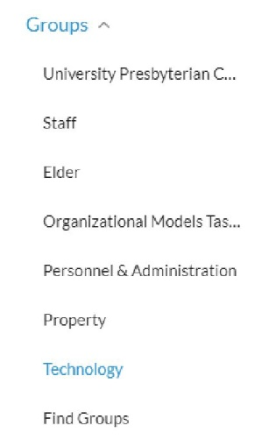
It’s been said that Facebook is the social media tool for individuals while Realm is the social tool for Groups. Realm is focused on making church groups work better through communication leading to improved ministry. You can quickly access your groups by expanding Groups in the left navigation pane and selecting your group of interest.

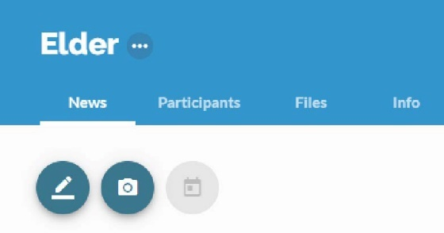

When in a group site such as Elder shown above, there are many functions available to members of the group. Use the three circular icons to add a new post, add a photo, or add a calendar event. The five Group tab menu functions described below.

- News will provide all the posts and events activities with the most recent activities at the top. Select any of the posts or events to reply and add to the discussion. If you attach a file to your post then the file will show both within your post as well as the Files tab.
- Participants will show all the members of the group. If you are a Group Leader then you will have additional information for each participant as well as a “Manage participants” button to add or remove a participant.
- Files is one of the best features in Realm. It provides a central place to share files within your group. As an example, the Elder currently shares files for The Book of Order, The Book of Common Worship, and Session Agendas. This way, Committee information is always available for all current committee members even if the author of the file leaves the committee.
- Attendance is an optional feature but is very handy if it is important to track who attends a committee meeting or event. Typically, only a Group Leader would have rights to take attendance on Realm. A requirement is to first setup a calendar event. Those events will show under the Attendance tab after the date of the event. All group participants are shown so the Group Leader can check the members that attended. Each event that had its attendance marked will remain under the Attendance tab for reference.
- Info shows the description of the group and lists the Group Leaders. It also provides a quick glace of the amount of recent activity in the group.

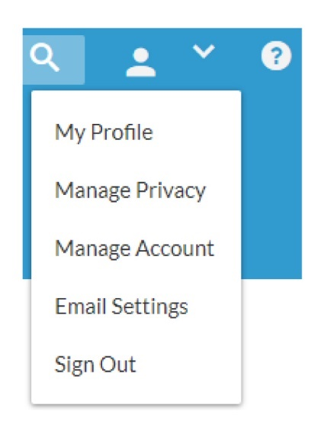
Profile & Account Settings
You can update your profile and account settings by selecting the drop-down menu from the person icon in the upper right corner as shown in the screen shot to the right. This is where you can update your personal contact information that will update the membership database used by the church office.

It is important that you at minimum review and update your Skills, Privacy, and Email Settings. Skills is where you enter your Time & Talents volunteer opportunities. You can select your volunteer opportunities here in lieu of completing a paper Time & Talent survey. Email Settings is where you select the frequency of your email notifications for each Group that you belong.

- My Profile – Select “My Profile” to review your contact information.

Then select “Edit Profile” to edit any of your contact or personal information. There is a “Contact Information” tab and “Personal Information” tab.

- Contact Information – select the “Contact Information” tab if not already selected. Edit any of your contact information shown as needed. Press “Save” at the bottom of the screen. Your updated contact information will integrate with the ACS People module used by the church office for all church communications. In this way you can maintain your family’s current contact information without having to contact the church office. This information is used for the church directory, church mailings, and email.
Personal Information – select the “Personal Information” tab to update your Time & Talent survey selections. This feature is currently in development.
- Skills – Scroll down to the skills area as shown in the screen shot below. If you have previously submitted a Time & Talent then those selections should already be shown. Use the drop-down to list all the skills and select the checkbox for all volunteer opportunities you wish to participate. A group leader will contact you about your participation with that opportunity.

• Manage Privacy – Privacy is in regards to your contact information such as address, phone, and email address that is shown to others on the University Presbyterian Church Realm site. No one outside Realm could ever see this information on Realm. By default, your privacy settings are set so only Group Leaders + Church Staff can see your contact information.

It is important that you change your privacy setting to “Everyone in Our Church” so your contact information is available to everyone in the Realm Directory. This will make the Directory much more useful to everyone. Remember that all church members already have access to this information though the hardcopy church directory. So, enabling others to see your contact information on Realm really does not threaten your privacy but rather makes it more convenient for members to communicate with each other.

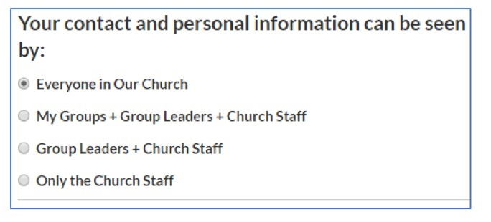
• Manage Account – this is where you can change the password for your account.
• Email Settings – select “Email Settings” to personalize the frequency of email notifications for each group that you belong. It is recommended to select “All content and replies” for each group so you don’t miss any group communications. Once you make a selection the setting is saved.

To further improve your notifications, it is recommended that you also download the Realm Connect mobile app from the App Store or Google Play. That way you will get instant notifications through your smartphone without relying on email. Go to the “Download the App” section for instructions to download and setup the app.

• Sign Out – select “Sign Out” to log out of Realm. However, if you do not sign out, Realm will keep you logged in as a convenience so you will not have to sign back in the next time you open Realm.

Download & Use the App
Using the free Realm Connect app on your mobile device will significantly improve communications of all Realm posts and calendar events for the University Presbyterian Church group and all other groups that you belong. Once downloaded, notifications are setup specifically for the app and is separate from the email settings in the web version of Realm.
You must first have setup a Realm account and confirmed you are able to login to the web version of Realm before proceeding. Remember your login credentials for use in the app.
Download the app using your Apple or Android smartphone or tablet. If you have a large screen tablet then it is best to use the web version of Realm since app functionality is limited to submitting and reading posts and calendar events. For example, you cannot access the Church Directory on the app at this time although that is coming in a future app release.

To download and setup Realm Connect app…
- Go to the App Store (Apple) or Google Play (Android). Search on “Realm Connect”.
- Select and download the app

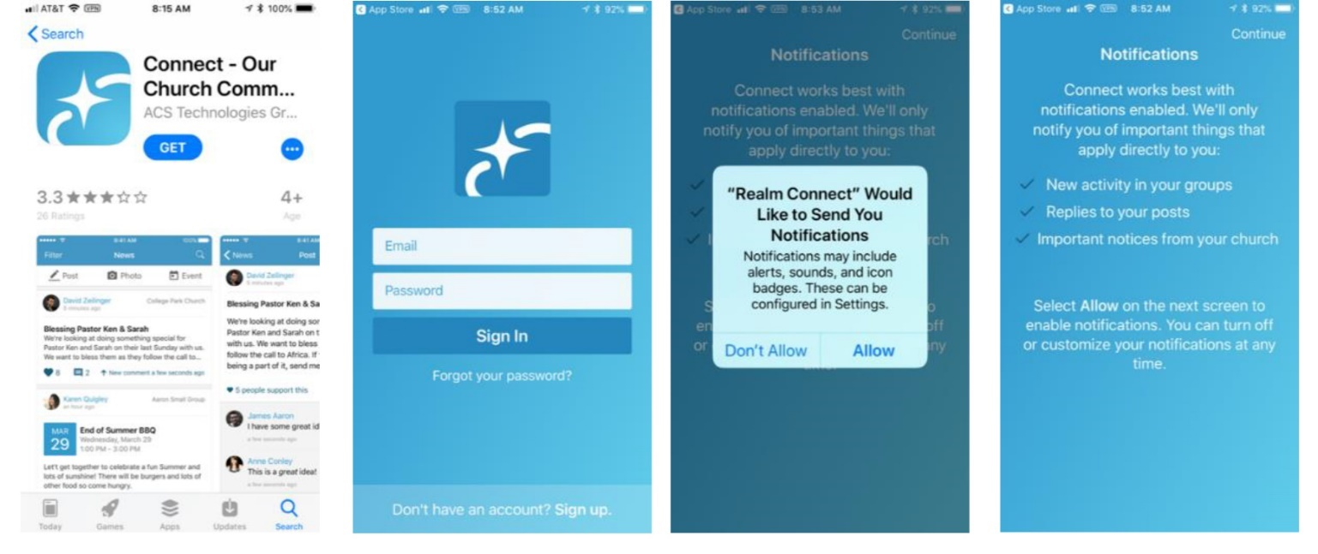
- Open the Realm Connect app and enter the same login credentials used in the web version of Realm. If you enter incorrect login credentials, you may be prompted for an invite code. If you receive that prompt, go back to the login and reenter the correct login credentials. Remember that your username is the email address used to setup your Realm account. If you do not remember the email address used then contact Caralyn in the church office for help to identify the email address used for your account.
- Once you have access into the Realm app it typically does not prompt for login credentials again. Going forward, when you open the app it will go directly to your News feed.
- Set your Notification Settings for your groups. At the bottom of the app screen, select “More” > Settings.
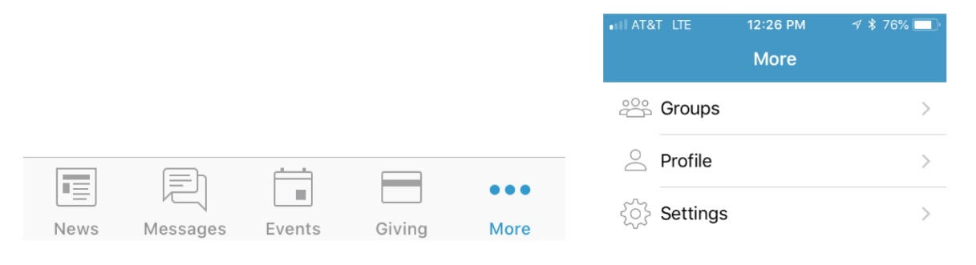
- Your Group Notifications are shown listing all your groups. Select a group and then update the level of notification to either “All content and replies”, “New content only” or “Nothing”. If you are active in the group then it is recommended to set the notification to “All content and replies” so you get all communications instantly for your group.

You can use the app through the News, Messages, Events & Giving icons at the bottom of the screen.
- News – News provides the most recent activities for all of your Groups. If you have new activity it will show the number of new postings in a red circle by the icon. You can select any of the new posts and reply if necessary, from there.
- Post – If you need to start a new post for one of your groups then select the Post icon at the top of the News screen. Select the group you want to submit your new post. If your post is to multiple groups then enable the “Post to multiple groups”. Enter a title and content and press “Post” when done.
- Photo – Likewise to posts, you can select one or multiple groups to upload a photo. Realm will ask you to allow it to access your photos. Select OK and then select your photo for upload.
- Event – You can add calendar events to any of your groups. Typically, you have to be a group leader to add a new event. Enter the event Title, details, Start Time, End Time and Location. You also have the option to setup a recurring meeting by selecting a Frequency. You can select weekly, every two weeks, or monthly based on the Start Time.
- Messages – Messages provides a way to send a note to specific people at UPC. Even if they do not have a Realm account, Realm will send an email to them with your message. The advantage of using Messages instead of email is that you never have to remember an email address. You just start typing their name and the matches will pop up for you to select.
- Events – These are calendar events for all of your groups. An event could be a congregation-wide event posted by the church office or it could be a committee meeting posted by the Committee chair. Events provides an easy way to organize all the meetings you are invited to attend. If you respond that you will attend an event then Realm will send you a reminder the day prior to the event. Note that the Events section is where you can review all events that have already been setup. If you need to create a new event then you would do that in the News section.
- Giving – Giving will show both your history of gifts and pledges going back to 2008. Giving is integrated with the ACS Finance module to provide your giving history in a safe secure manner.

NOTE:
No one except you and the Church office has the ability to view your giving information.
If you have questions about any of the giving information, please contact Caralyn in the church office.

Realm Online Documentation & Videos
For more information on using Realm please refer to the ASC Technologies Realm website for extensive online documentation and training videos. Here are some quick links to recommended help content on Realm…
- Overview – high level description of Realm with 1:16 minute video https://www.acstechnologies.com/products/realm
- Self-Guided Tour – series of videos to introduce you to Realm and highlight different ways it can support our ministries. Recommend setting aside 30 minutes for the tour. https://www.acstechnologies.com/products/realm/demo/tour?utm_source=site&utm_medium=cta&utm_campaign=sgt
- Congregants Help – Help documentation for common Realm user functions http://help.onrealm.org/?rp=Connect&ap=None&np=None&lp=Groups+Group+Members+and+Leaders#realm_congregants_landing.html
- Group Leaders Help – Help documentation focused on Group Leader functions and privileges to maintain their group. http://help.onrealm.org/?rp=Connect&ap=None&np=None&lp=Groups+Group+Members+and+Leaders#realm_leaders_landing.html

